**Stage 7 – This is from... Mathilda**

**COURSE DESIGNER:** Ike Starnes

|  |
| --- |
| **SCORING:** Comstock 24 rounds.  **TARGETS:** 12 cardboard targets  **SCORED HITS:** 2 Best hits per carboard will be scored. |

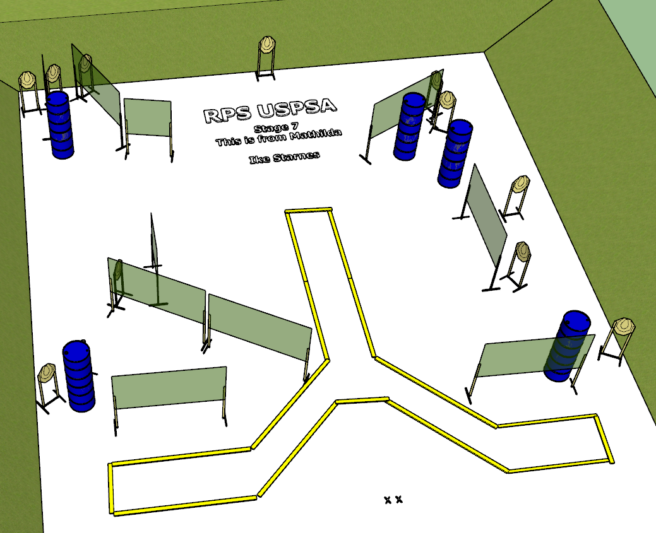

**Written Stage Briefing:**

**Stage 7 – This is from... Mathilda -** is a 24 round, 120 point, Comstock Long Course. There are 12 cardboard targets. The best 2 hits per cardboard target will be scored.

**Start position** Both feet on the Shooting Sports Innovations Xs, facing generally downrange.

**Handgun: Unloaded and holstered, wrists below belt.**

**PCC: Unloaded, held in both hands, stock touching belt.**

On the audible start signal, engage targets from within the shooting area.

**USPSA / NROI Range Commands:**

* Make Ready
* Are you ready?
* Standby
* If finished, unload and show clear.
* If clear, hammer down and holster
* Range is clear

**Setup Notes:**

16 Single Wall Stands

7 Double Wall Stands

3 Full Walls

3 Half Walls

12 Target stands / 24 target sticks

1 Starting Xs

10+ barrels

